# Student Teacher Meeting Appointment

**Overview:**

The Student-Teacher Meeting Appointment app allows students to make appointments with teachers and for a teacher to manage and view appointments. The application comes with a login system for both students and teachers and has separate dashboards for both.

**Features**

**User Authentication**: A user can register either as a student or a teacher and log in to the application.

**Dashboard:**

Students have an appointment creation feature, can see their appointments, update their profile, and log out. Teachers can view appointments, update their profile, and log out.

**Appointment Scheduling:** The student will select a teacher from a list of available teachers, choose a date and time, fill in the description for the meeting.

**Appointment Management:** The scheduled appointments should be available on both the dashboard of the students and the teacher.

**Technology Stack:**

Frontend: HTML, CSS, JavaScript

Backend: Node.js, Express.js

Database: MySQL

Password: Hashing bcrypt

**Setup and Installation**

**Prerequisites**

* **Node.js** (v14.x or later)
* **MySQL** (v8.x or later)

Start the Node.js server:

* node server.js

Open your browser and navigate to <http://localhost:3000.>

**Website Pages**

The web pages involved in the project:

1. admin.ejs
2. dashboard.html
3. login.html
4. profile.ejs
5. register.html
6. schedule.html
7. student-appointments.ejs
8. style.css
9. teacher-appointments.ejs and
10. Final server.js (back-end code).

# Registration(register) page:

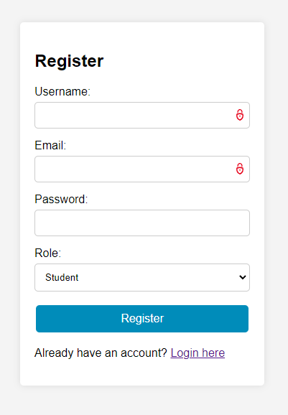

1. Username field: the user should enter the name that they want to enter at the time of their login.
2. Email field: the user should enter the email id ending with [“@gmail.com](mailto:\“@gmail.com)” else gets the page asks to enter the valid email.
3. Password field: To ensure security, the password if entered is hidden.
4. Role field: consists of 3 roles student, teacher and admin.
5. Register button: allows the user to register to the page.
6. The page is connected to the database student teacher meeting appointment and added one user in user table, username and password are added to the table.

# Login page:

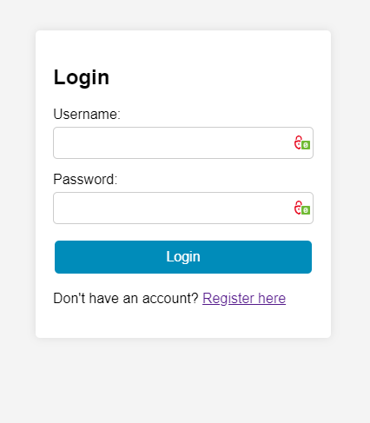

1. Username field: user should enter the username that they user at the time of registration.
2. Password field: To ensure security, the password if entered is hidden.
3. Login Button: To submit your credentials, click the blue "Login" button.

# Dashboard:

The dashboard looks as shown below: 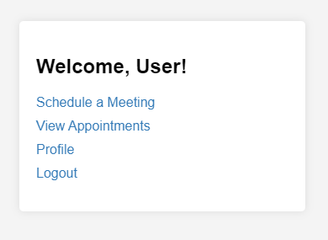

The dashboard consists of 4 href links:

1. Schedule a Meeting: which redirects to a page where a student or admin can schedule meetings with the teacher.

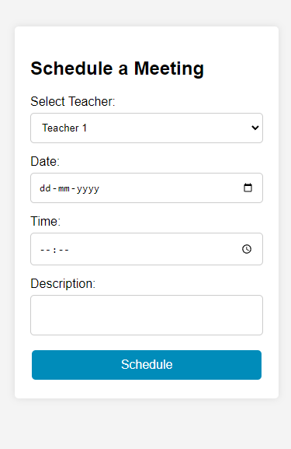

Which only student and admin are able to access.

1. View Appointments: which is redirected to a page where a student can see all the appointments that they made,

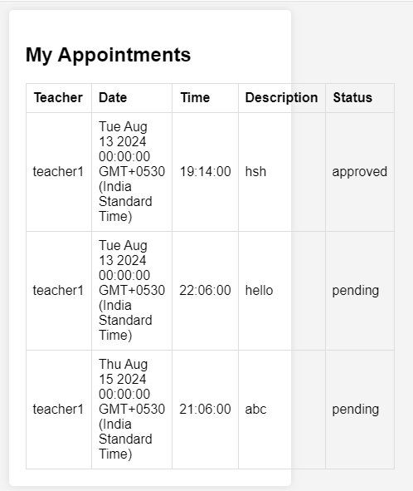 a admin and teacher can see all the appointments of all students where the admin and teacher can approve or delete the appointment

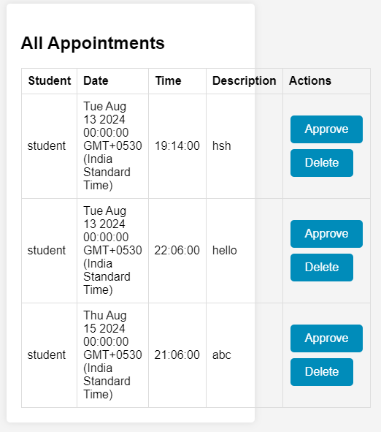

1. Profile: where the user can see all the details that they entered at the time of registration.

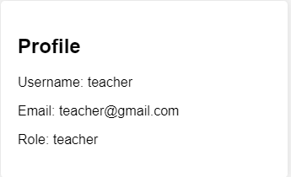

1. Logout: where the page gets redirected to the login page.

